Fire and emergencyinstructions
XXXXXXXXXXXXXX

Call the fire brigade, phone: 1-1-2
- What is the address: XXXXXXXX
- Which phonenumber are you calling from?
- What has happened?
- Are there any injured – how many?

ALERT THE REST OF THE STAFF/OCCUPANTS ABOUT THE SITUATION
  - If possible - activate the internal warning

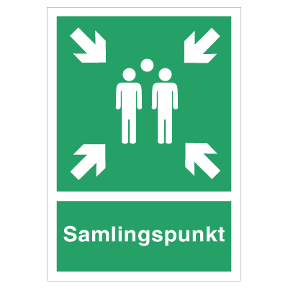EVACUATE THE BUILDING
  - Rendezvous:

MAKE USE OF THE FIREEXTINGUISHERS
UPON ARRIVAL THE FIRE BRIGADE MUST BE INFORMED ABOUT
  - Are there any persons left in the building – where are they?
  - Location of the fire?
  - What is on fire?
  - Access to the building?

